**PHASE END PROJECT1**

**SCREENSHOTS**

**TO ADD PLAYER:**

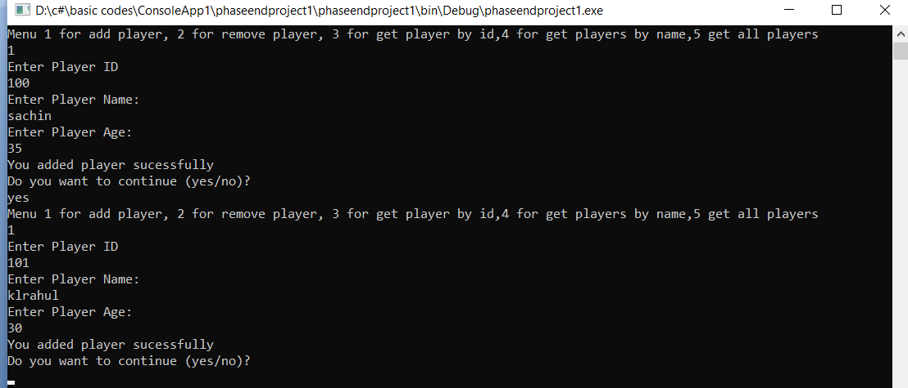

**TO REMOVE PLAYER:**

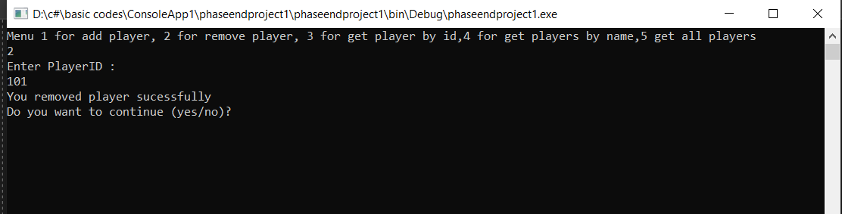

**TO GET PLAYERS BY PLAYER ID:**

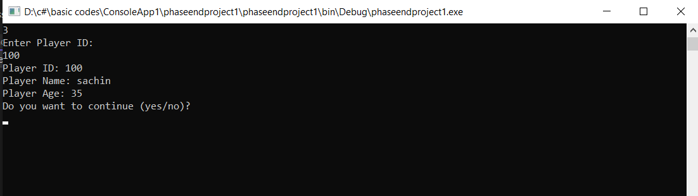

**TO GET PLAYER BY PLAYER NAME:**

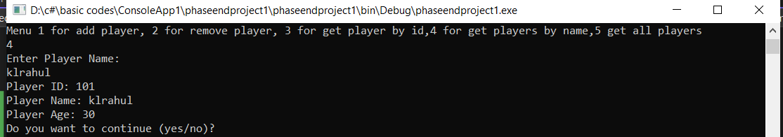

**GET THE PLAYERS DETAILS CURRENTLY PRESENT:**

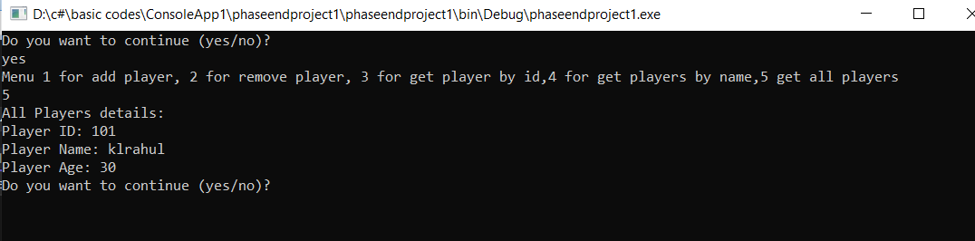

**FULL OUTPUT WINDOW:**

